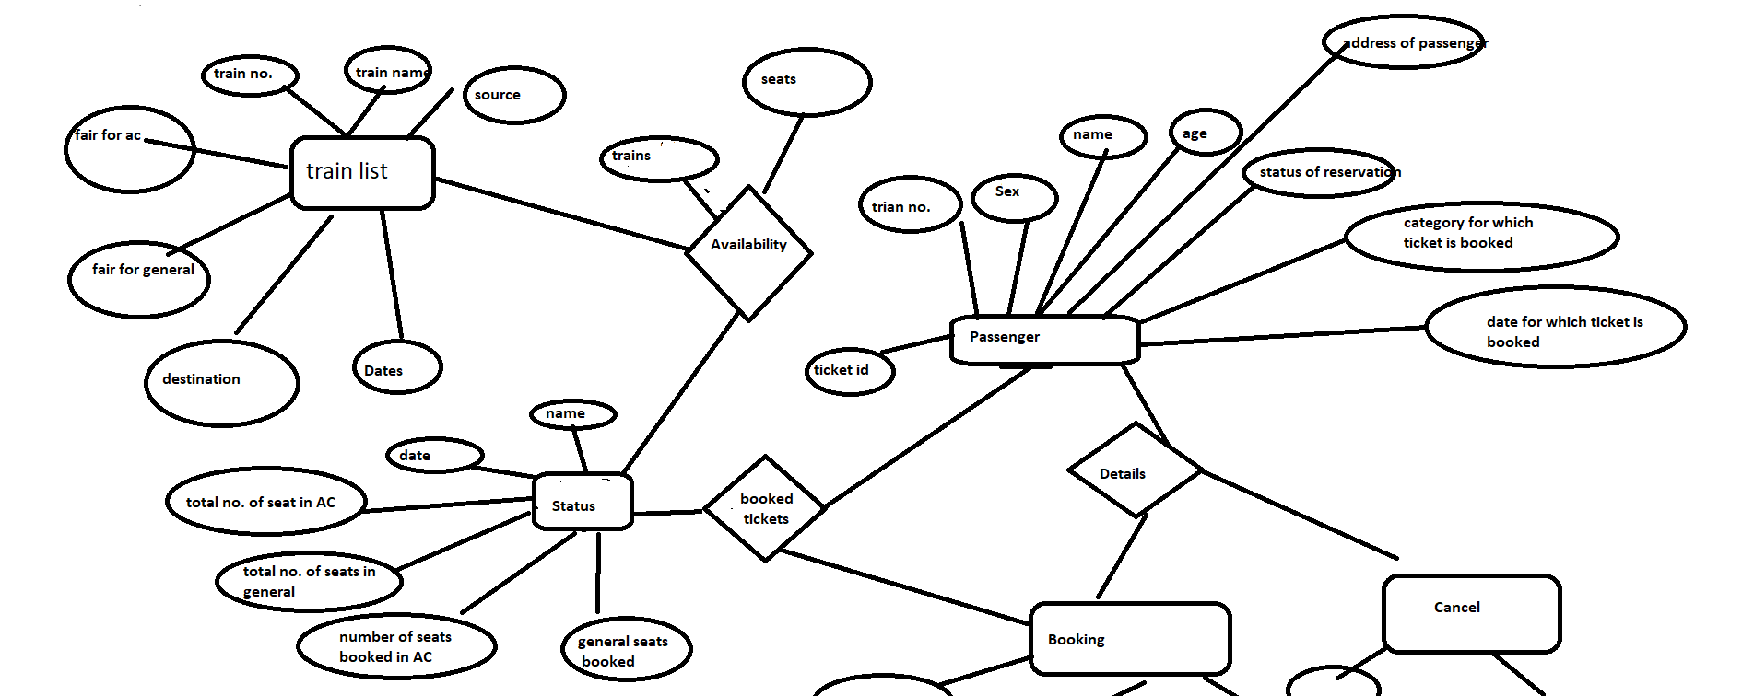

Table:-

TrainList(

TrainNumber PRIMARY KEY,

TrainName,

Source,

Destination,

Fair_ACseats,

Fair_Generalseats,

Weekdays,

CONSTRAINT ( Count(TrainNumber) <= 5 )

)

Passenger(

TicketID PRIMARY KEY,

TrainNumber,

Status,

BookingDate,

Name,

Age,

Sex,

Address,

Category,

Status

)

Train_Status(

TrainNumber PRIMARY KEY,

TrainDate,

TotalBooked_AC,

TotalBooked_General,

TotalSeats_AC,

TotalSeats_General

)

Book(

TicketID PRIMARY KEY

TrainNumber

BookStatus

BookingDate

)

Has_Status(

TrainDate

TrainNumber PRIMARY KEY

SeatsAvailable_AC

SeatsAvailable_General

)

Cancel(

TicketID PRIMARY KEY

CancellationDate

)